## **Sam agent**

## **Pre-requisites:**

* Sam agent setup file 'SummitAssetAgent.exe' setup file must be downloaded

**URL:** <https://www.symphonysummit.com/>

**Note:** Sam agent setup file 'SummitAssetAgent.exe' setup binaries will be provided by Vendor as per request because Sam agent setup is a Licence software.

* User should have administrator rights to install the Sam agent setup file 'SummitAssetAgent.exe

## **Installation:**

* + 1. Log in to the machine where Sam agent will be installed.
    2. Navigate to the directory where 'SummitAssetAgent.exe' file is copied.
    3. Double click on 'SummitAssetAgent.exe'. After that the 'Summit Asset Agent Setup Is preparing the InstallShield Wizard' Process will be started and 'InstallShield Wizard' windows will be opened.

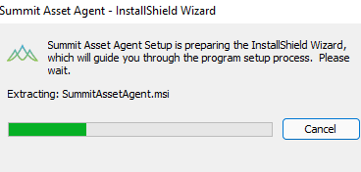

Fig. 2.1 InstallShield Wizard

* + 1. Click on 'Next' Button. After that 'License Agreement' windows will be opened then Click on 'I accept the terms in the license agreement’.

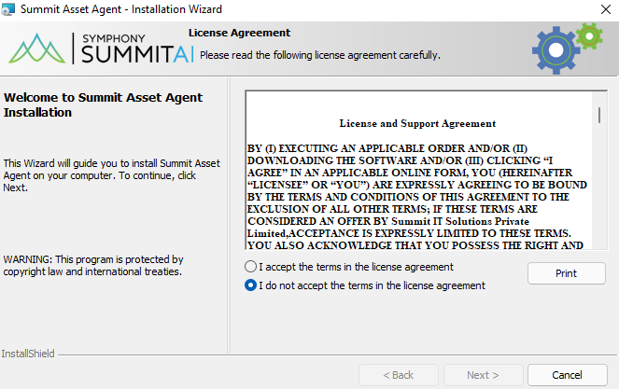

Fig. 2.2 License Agreement

* + 1. Click on 'Next' Button. After that 'Destination Folder' windows will be opened.

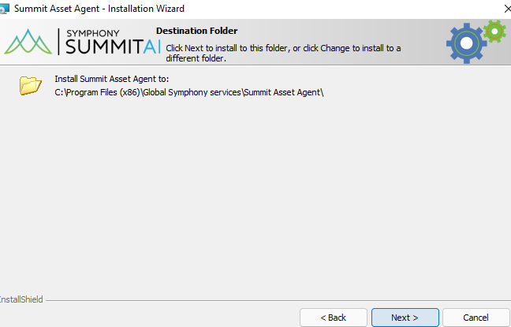

Fig. 2.3 Destination Folder

* + 1. Click on 'Next' Button. After that 'Ready to Install the Program' windows will be opened.

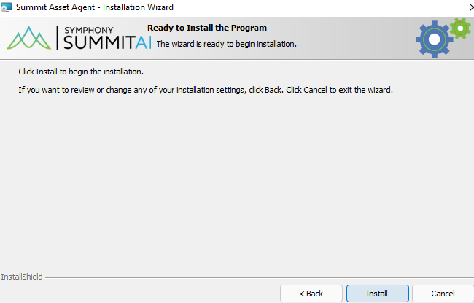

Fig. 2.4 Ready to Install the Program

* + 1. Click on 'Install' Button. After the installation 'Installing Summit Asset Agent' windows will be opened.

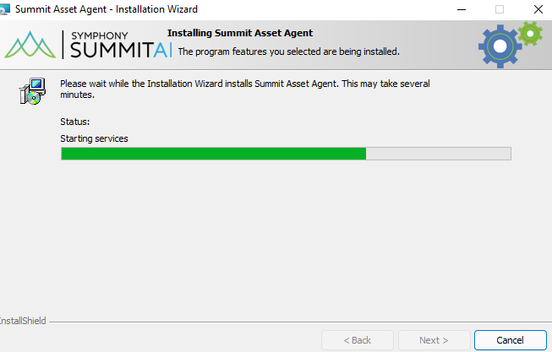

Fig 2.5 Installing Summit Asset Agent

* + 1. Then Click on 'Finish' Button.

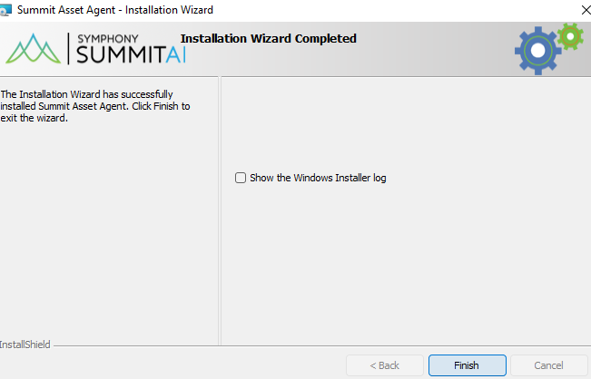

Fig 2.6 Installation Wizard Completed

## **Verification:**

* Open 'Control Panel'.
* Navigate to 'Programs\Programs and Features'.
* 'Summit Asset Agent’ must be present in the installed software list.

